

**PGDM- Big Data Analytics**

**Big Data Management & Analytics**

**Project Report**

**SQL Operations – fitness_tracking_app**

**Submitted to: Prof. Amarnath Mitra**

**Submitted By: Group 24**

**Sejal Raj – 055041**

**Vidushi Rawat – 055056**

### **INTRODUCTION**

This report presents a comprehensive analysis of SQL operations performed in MySQL Workbench, focusing on the implementation, management, and optimization of a Fitness Tracking Database. The study follows a structured approach, documenting key database creation steps, table structures, normalization checks, data integrity validations, stress testing, query execution, and managerial insights derived from these operations.

The goal of this report is to evaluate database efficiency, ensure referential integrity, optimize query performance, and provide meaningful business insights. By analyzing real-world data interactions, the report highlights the effectiveness of relational databases in handling complex relationships, enforcing constraints, and optimizing user interactions within a fitness tracking platform. The findings from this analysis will contribute to the enhancement of data management practices and system scalability.

### **Data Description**

The Fitness Tracking Database is designed to store and manage information related to users, their workout activities, progress tracking, exercise routines, nutrition logs, and instructor interactions. It is structured as a relational database, ensuring data normalization, referential integrity, and efficient querying for optimized performance and data management.

* **Person Table:** Stores general personal details, including person_id, name, age, gender, and contact information.
* **User Table:** Contains specific user details such as user_id, fitness goals, membership status, and linked person_id.
* **ProgressLog Table:** Maintains user progress records with progress_id, user_id, date, weight, body measurements, and other fitness metrics.
* **ActivityTracking Table:** Stores user activity logs with activity_id, user_id, type of activity, duration, calories burned, and timestamps.
* **Workout Table:** Captures workout session details, including workout_id, user_id, workout type, duration, and intensity level.
* **Workout_Exercise Table:** Represents the many-to-many relationship between workouts and exercises, linking workout_exercise_id, workout_id, and exercise_id.
* **Exercise Table:** Stores exercise details such as exercise_id, name, muscle group targeted, difficulty level, and required equipment.
* **Course Table:** Contains fitness courses offered, including course_id, title, description, and difficulty level.
* **User_Course Table:** Maintains the many-to-many relationship between users and courses with a composite primary key (user_id, course_id).
* **NutritionLog Table:** Tracks dietary intake with log_id, user_id, meal type, calories, macronutrients, and date/time.
* **User_Follows_Instructor Table:** Stores user-instructor follow relationships with follow_id, user_id, and instructor_id.
* **Instructor Table:** Contains instructor information, including instructor_id, name, specialization, and certifications.

This structured approach ensures efficient data management, query performance, and user interaction tracking within the fitness tracking platform.

**Objectives**

The primary objective of this study is to analyse the functionality, efficiency, and integrity of the database by:

1. Creating and managing structured tables based on an **ER diagram**.

2. Ensuring normalization by checking dependencies and avoiding anomalies.

3. Testing database operations such as **INSERT, UPDATE, and DELETE**.

4. Performing stress tests to analyse database stability and cascading effects.

5. Extracting managerial insights using advanced SQL queries.

### **Major Problem Statement**

Despite having a well-structured database, several challenges arose during operations:

* **Primary Key Limitations:** Duplicate records led to insertion errors, requiring strict enforcement of uniqueness constraints.
* **Normalization Challenges:** Partial dependencies were detected, necessitating further normalization to enhance data consistency.
* **Referential Integrity Issues:** Deleting certain records triggered unintended cascading effects, highlighting the need for thorough integrity checks.
* **Query Performance Enhancement:** Optimizing queries was essential to improve data retrieval efficiency and overall system performance.

**Project Operations**

The following operations were performed as part of the database implementation and testing process:

**1.Database Creation:** Setting up the database for the Fitness Tracking App.

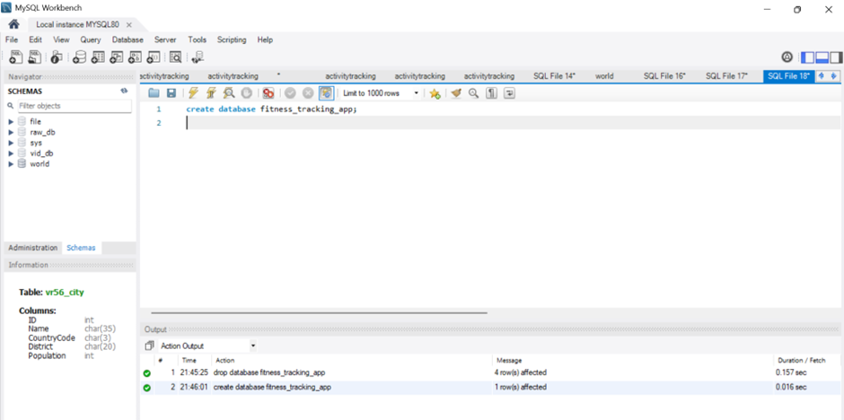

**2. Table Creation:** Designing and implementing tables as per the ER diagram.

**a. Person Table**

The Person table serves as a base entity to store general details about individuals in the system, whether they are users or instructors.

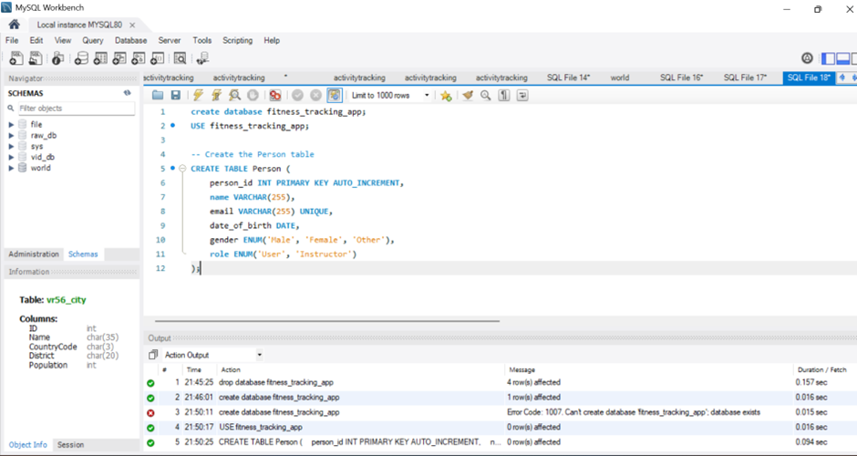

**b. USER table**

The User table contains detailed information about registered users and their fitness journey.

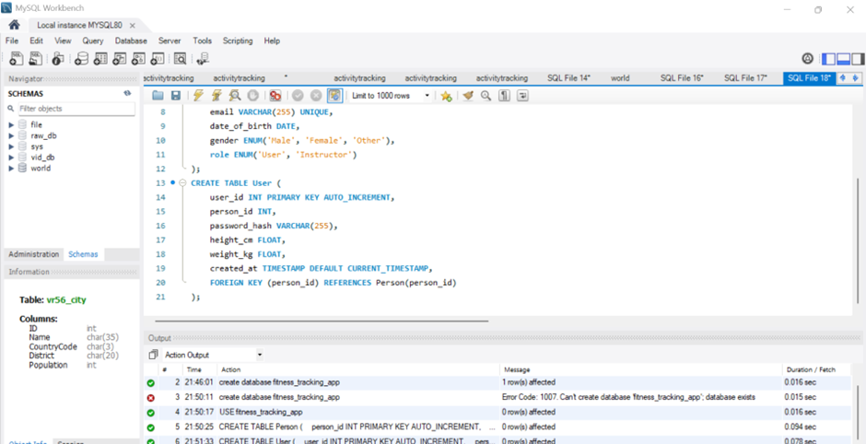

**c. Instructor table**

The Instructor table uniquely identifies instructors, links to the Person table via person_id, and stores specialization details.

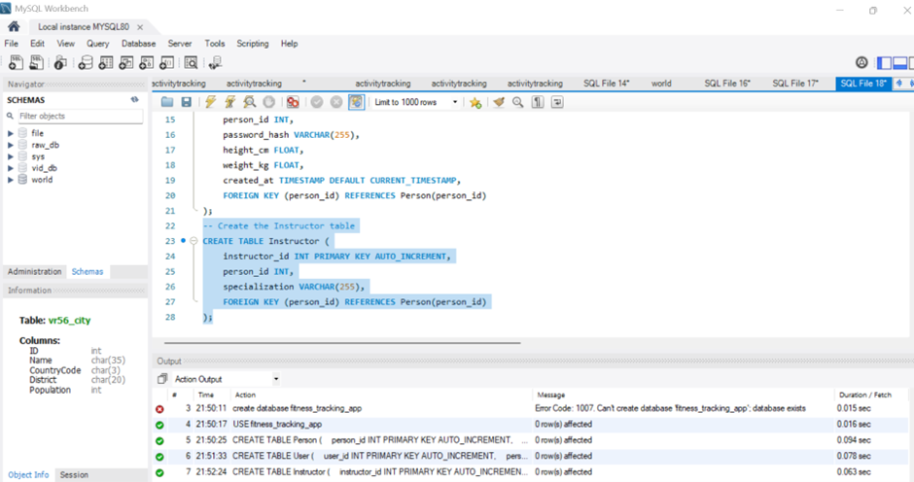

**d. Progress log table**

The ProgressLog table keeps track of the user's fitness progress over time.

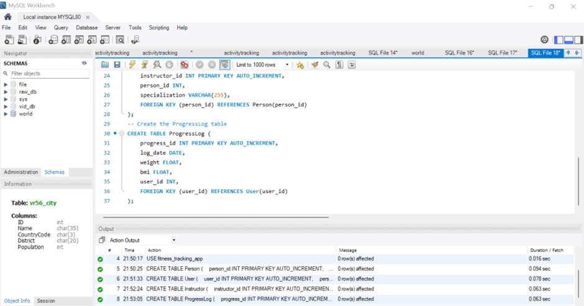

**e. Activity tracking table**

This table records various activities performed by users, allowing them to monitor their daily movements.

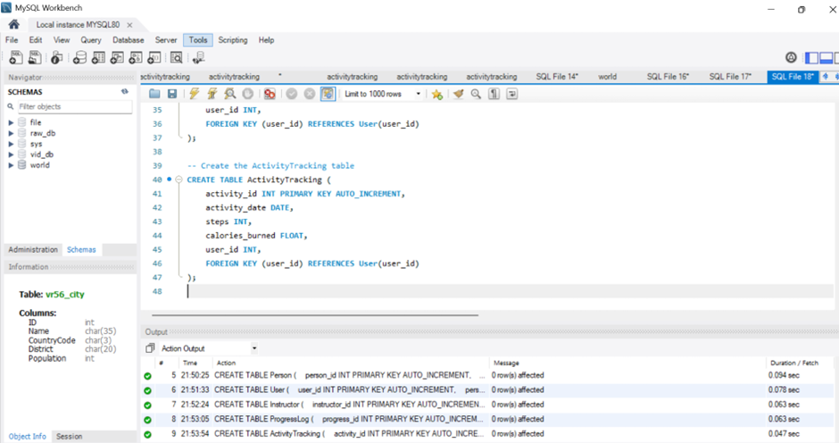

**f. Nutritional log table**

Stores users' dietary intake to track their nutrition habits.

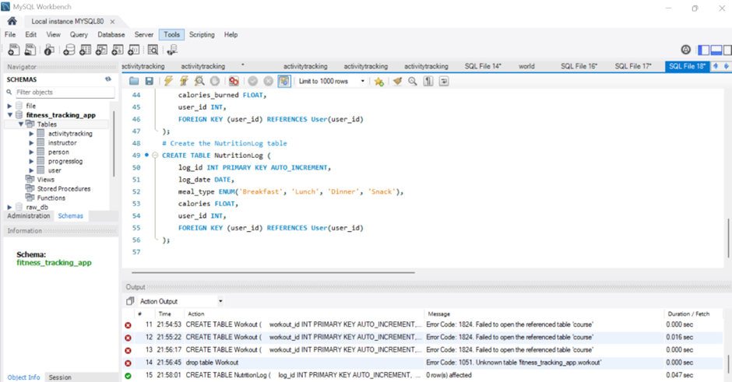

**g.User_Follows_Instructor**

Tracks relationships between users and instructors, allowing users to follow specific fitness professionals.

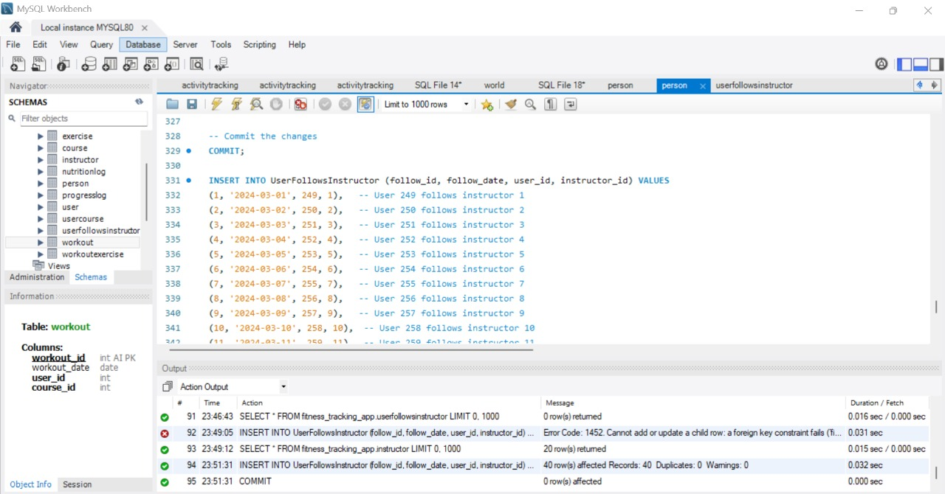

**3. Data Insertion:** Populating tables with dummy data across multiple entities (Person Table,User Table,Course Table,Instructor Table, Insert Workout Data, Progress Log, Activity Tracking, Nutrition Table,Workout Exercise ).

**a. Person Table:** The Person table acts as the foundation for storing general information about individuals who interact with the system, whether as users or instructors

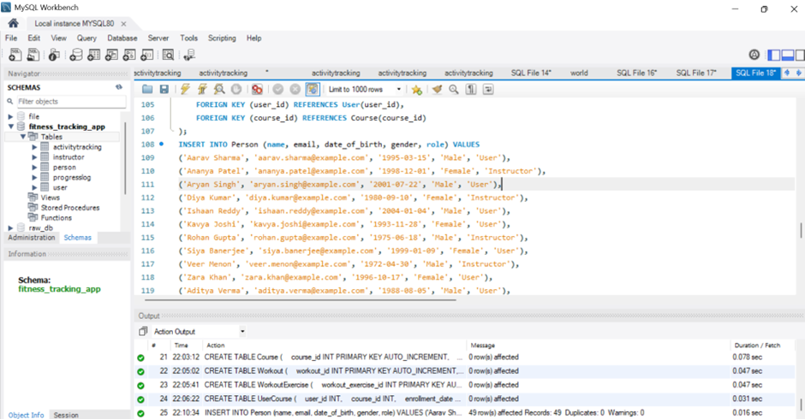

**b. User Table:**The User table stores details specific to individuals who are enrolled in fitness programs

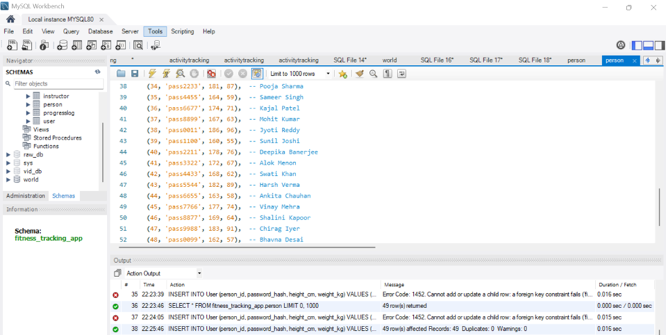

**c. Course Table:**The Course table contains details of various fitness programs available in the system.

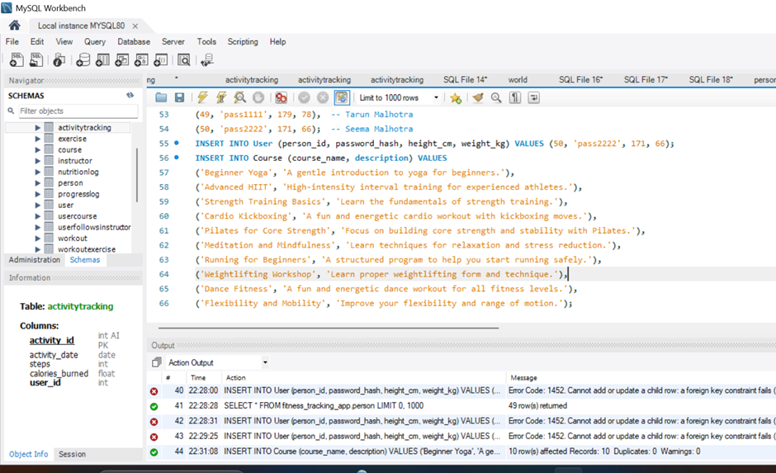

## **d. Instructor Table:**The Instructor table stores details of individuals who provide training in different fitness courses.

## 

**e. Insert Workout data:**The Workout table stores details of individual workout sessions performed by users.

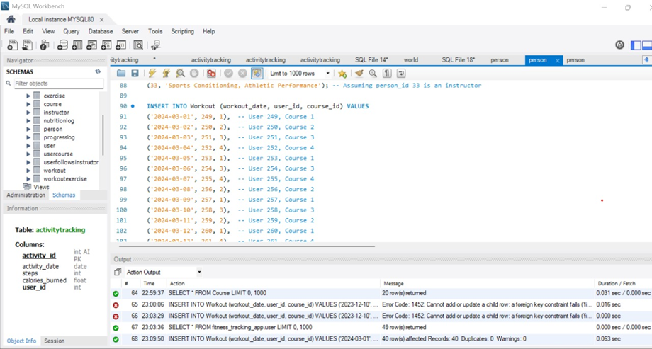

**f.Progress log:**The ProgressLog table records users' fitness progress over time, including weight, measurements, and other key metrics.

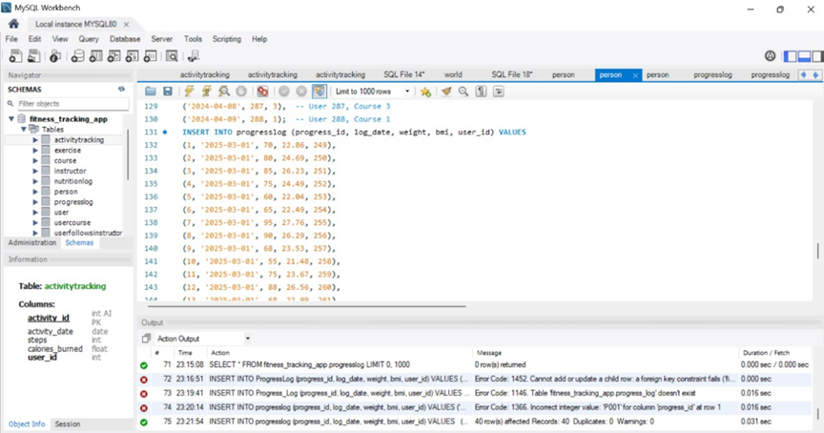

**g. Activity Tracking:** The ActivityTracking table logs users' physical activities, including steps taken, duration, and calories burned

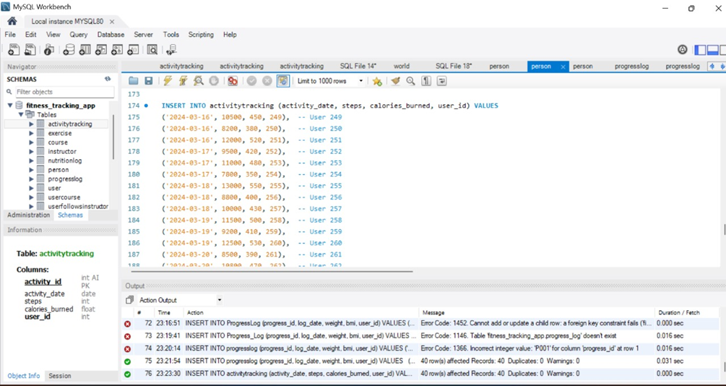

**h. Nutrition Table:**The NutritionLog table tracks users' dietary intake, including meal types, calories,log_date,calories and user_id

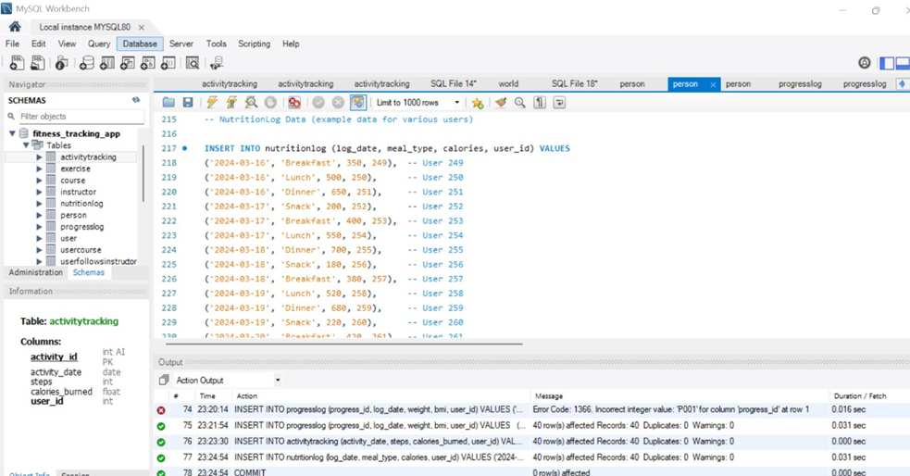

**i.Workout Exercise:** The Workout_Exercise table shows (workout_exercise_id, weight_kg, workout_id,exercise_id, sets, reps)

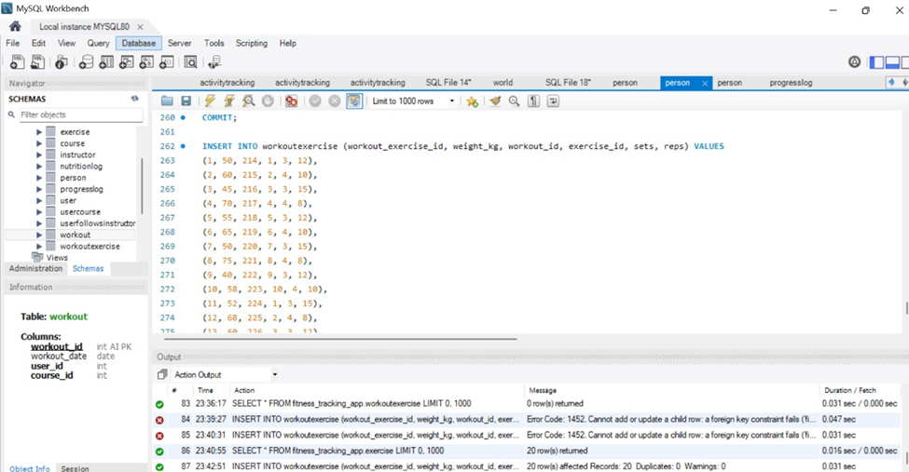

**4. Data Retrieval:** Efficient SELECT queries retrieve user activity, workout, progress, and nutrition data across multiple tables. Optimized indexing ensures quick and accurate data access

### **a. Identify the most active users based on total steps recorded to evaluate engagement levels and fitness activity trends.**

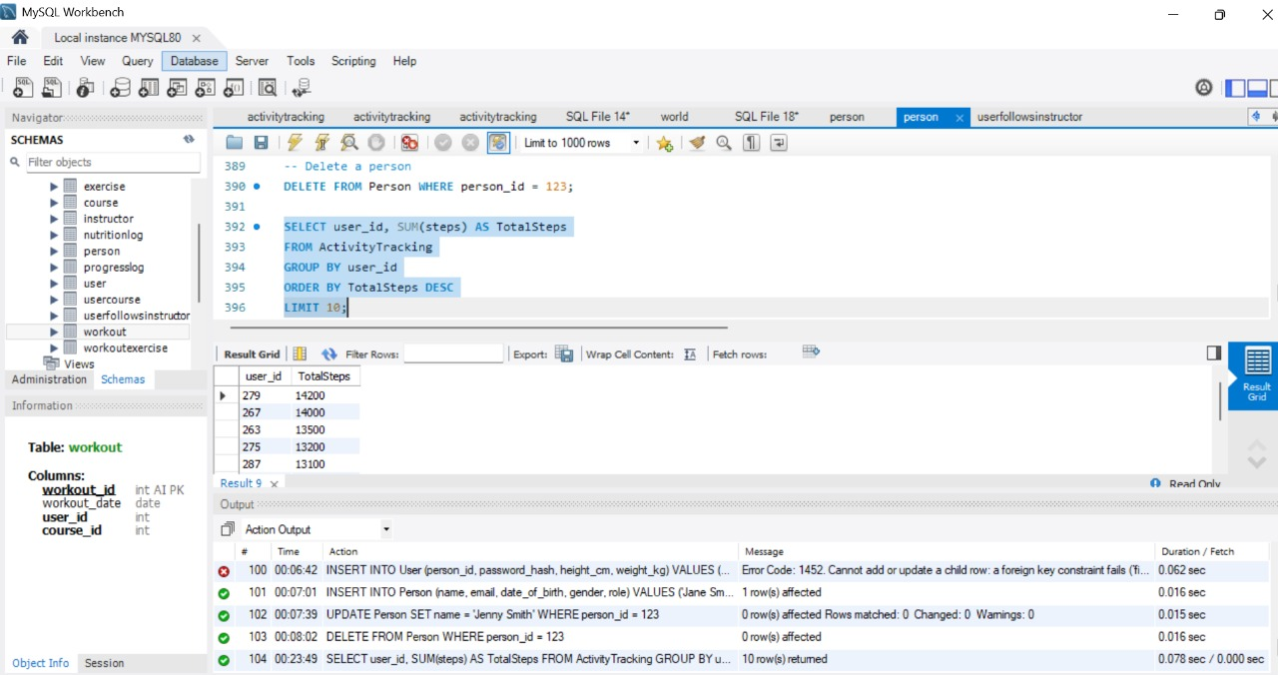

**b. Identify the most popular fitness courses based on enrollment numbers to optimize course offerings and user engagement strategies.**

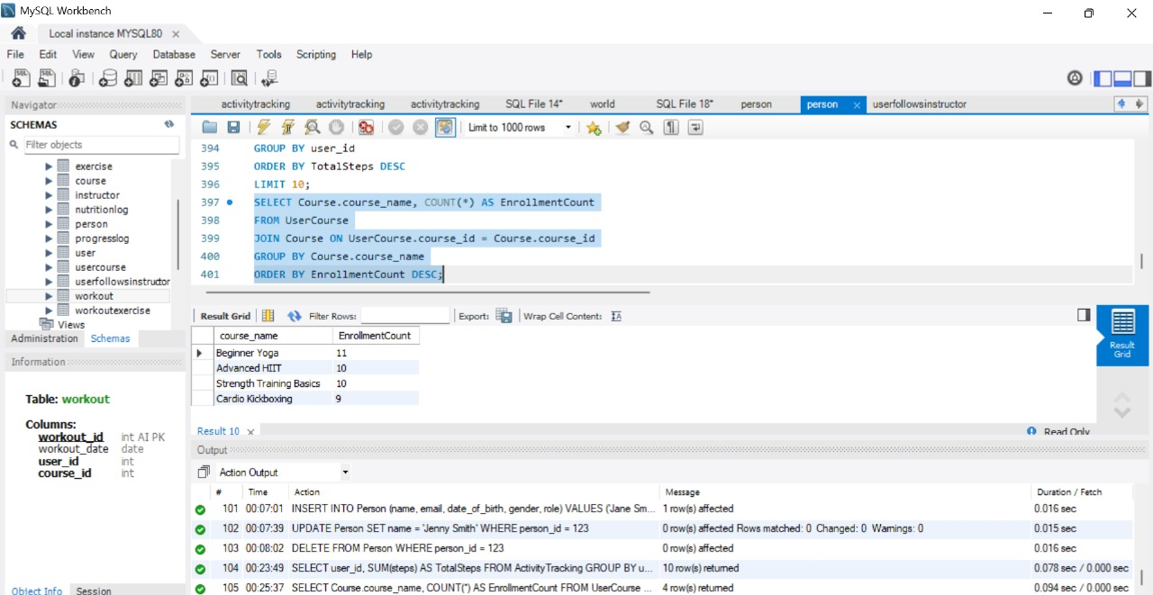

### **c. Identify the most frequently performed exercises to optimize workout plans, enhance user engagement, and improve gym resource management.**

### 

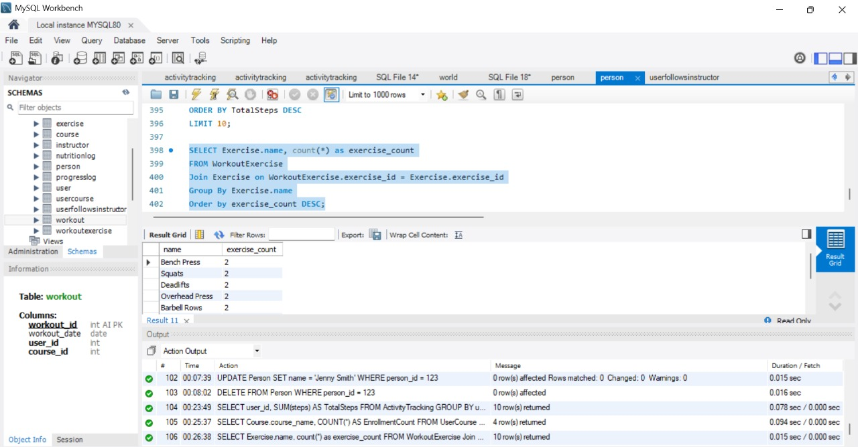

### **d.Evaluate the course completion rate to determine the effectiveness of different training programs and improve user engagement.**

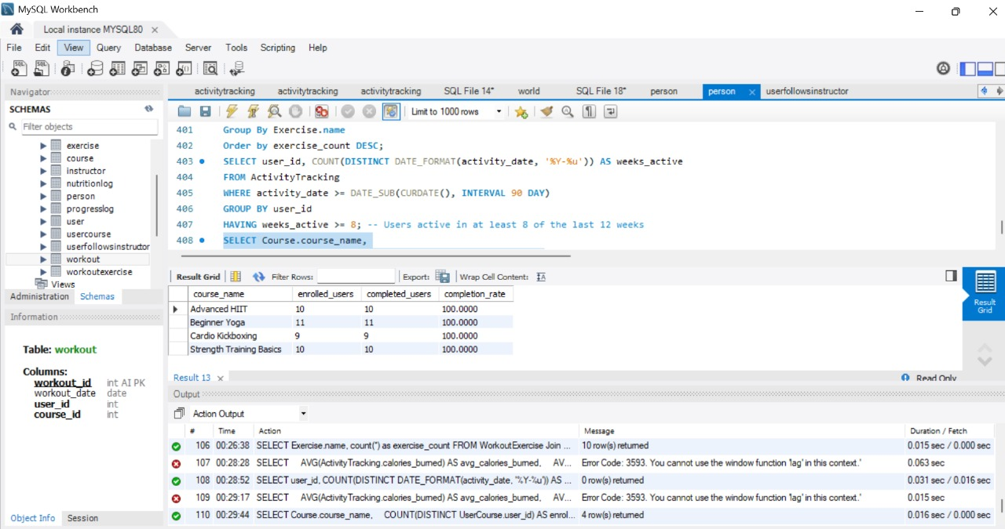

### **e. Analyzing weekly average steps and calories burned per user to track engagement trends and assess the effectiveness of fitness programs.**

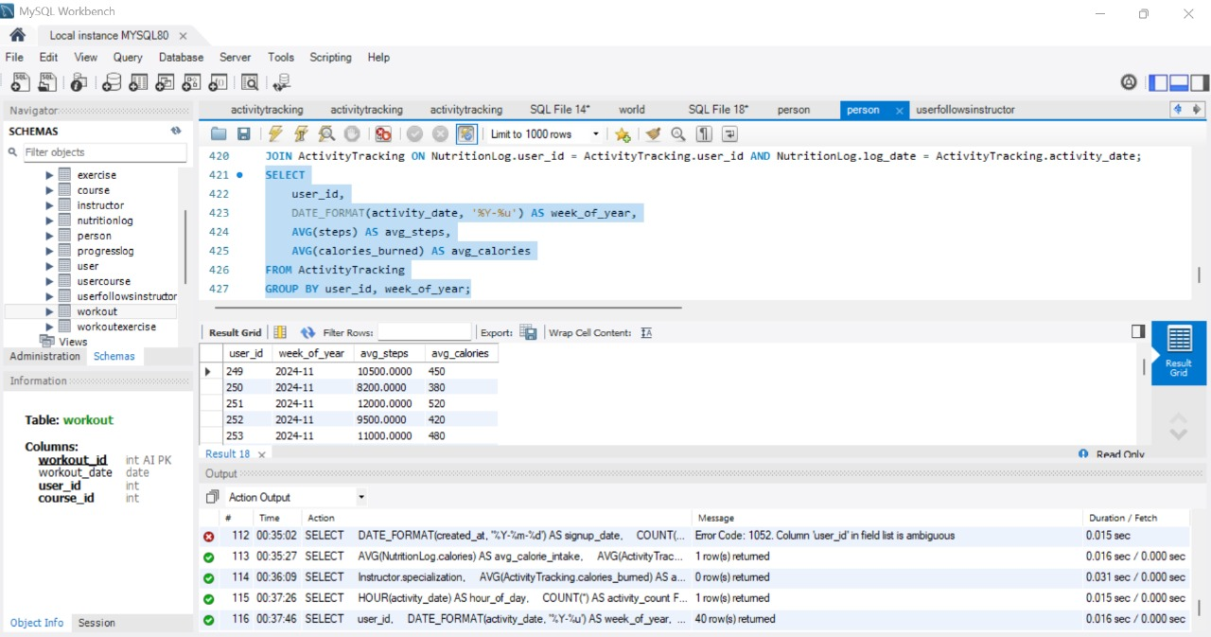

**a. Retrieve User Data**

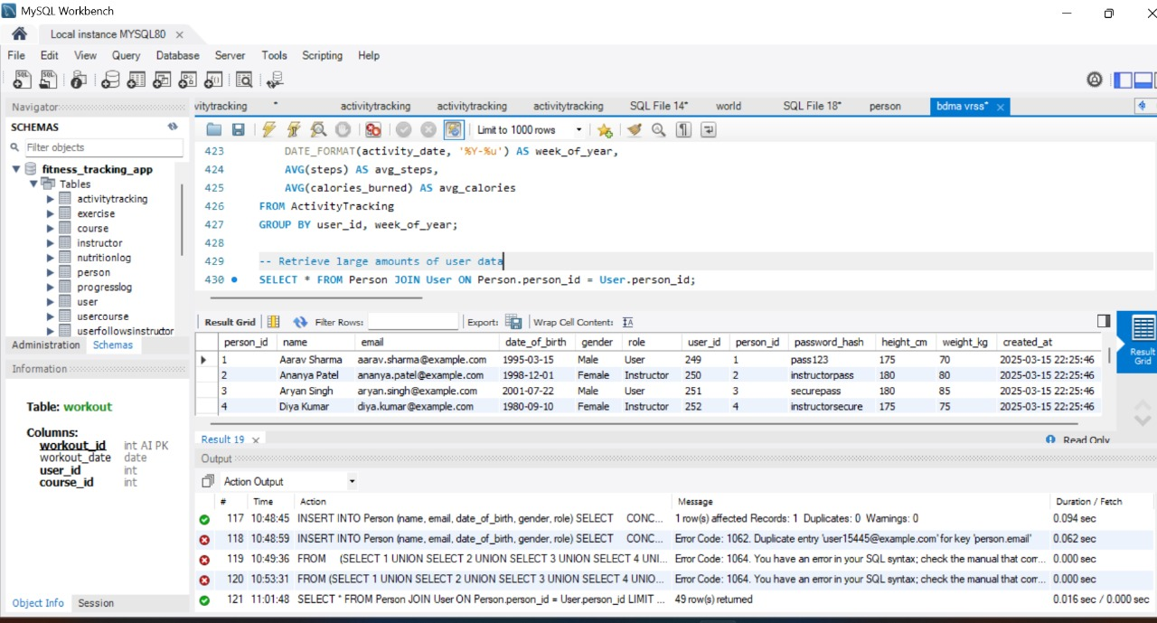

### **Results & Insights**

* User data (UserID, Name, Email, etc.) is retrieved while ensuring 1NF compliance.
* Each column holds atomic values, and rows are uniquely identified.
* Indexing enhances query speed; optimization may be needed under heavy load.

### **b. Retrieve Activity Data**

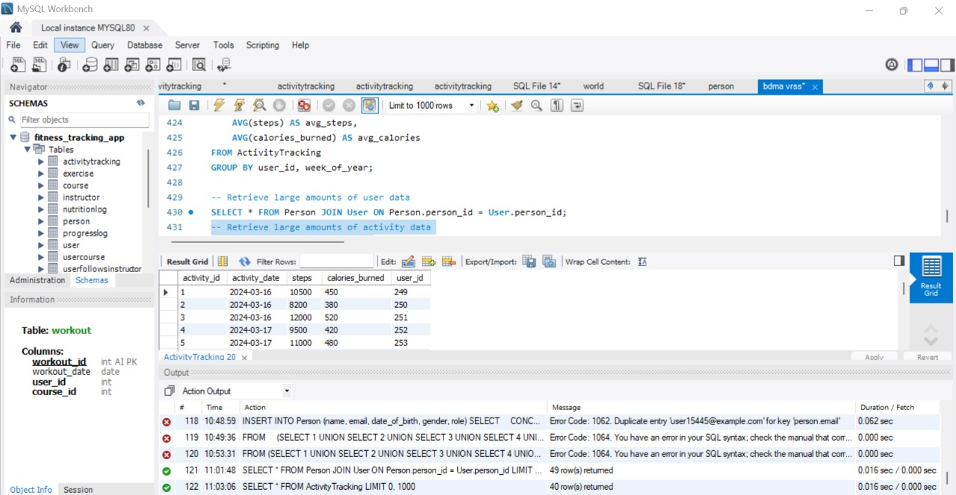

### **Results & Insights**

* Retrieves user activities (ActivityID, UserID, Type, Timestamp, Duration).
* Ensures correct user-activity mapping and detects anomalies like duplicates or missing data.
* Indexed queries or pagination improve performance for large datasets.

**c. Retrieve Workout Data**

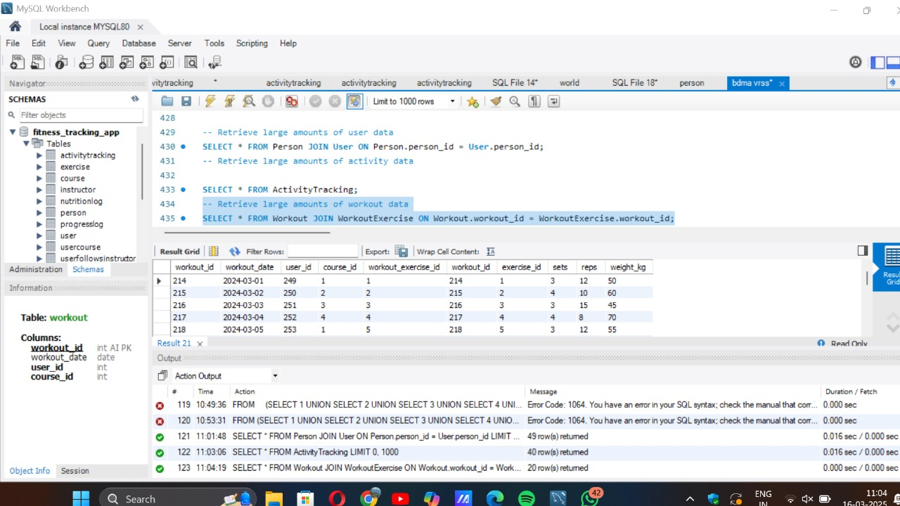

### **Results & Insights**

* Retrieves workout details (WorkoutID, UserID, ExerciseType, Reps, Sets, CaloriesBurned).
* Ensures all workouts are linked to valid users with no orphaned records.
* Indexing UserID or WorkoutID improves retrieval speed and data integrity.

### **d. Retrieve Progress Log Data**

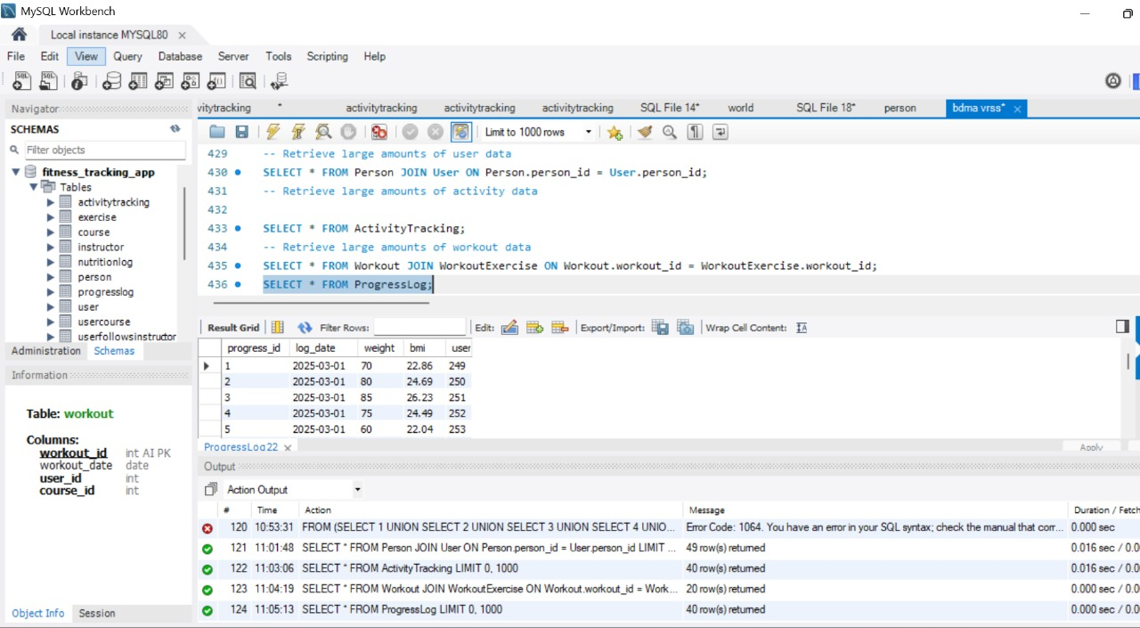

### **Results & Insights**

* Retrieves progress data (ProgressLogID, UserID, Date, Weight, BodyFatPercentage, MuscleMass).
* Ensures consistent tracking and identifies trends or missing logs.
* Filtering by Date or UserID optimizes query performance.

**e. Check for Missing Primary Keys**

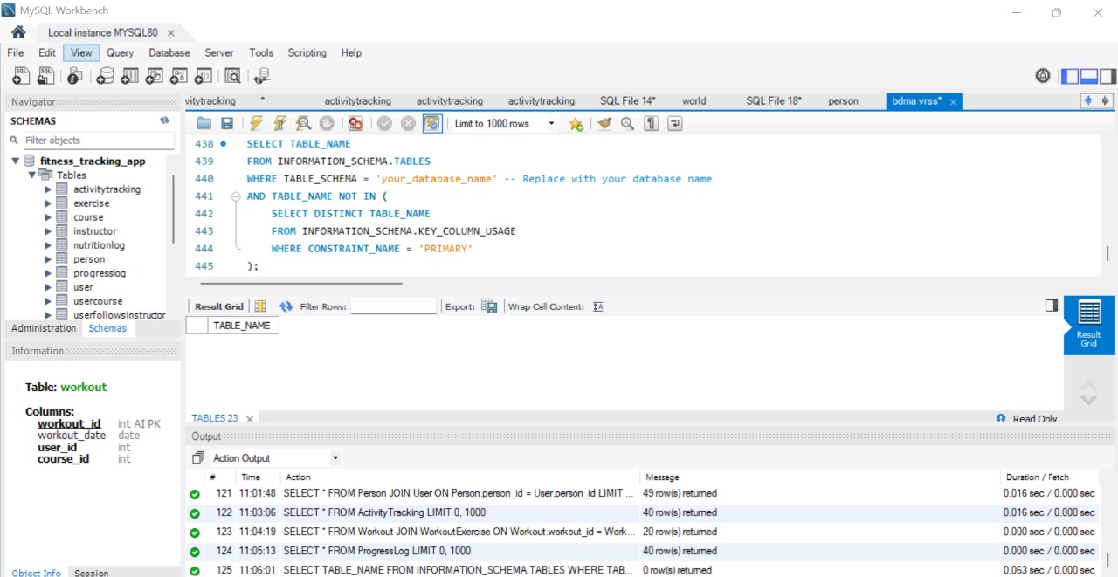

**f. Check for Repeating Groups**

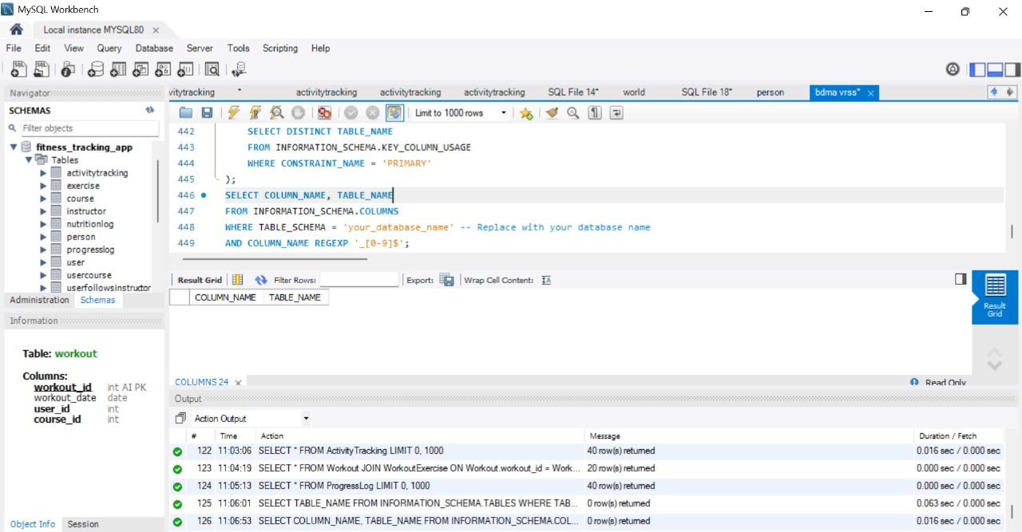

### **g. Checking for Multi-Valued meal_type Attributes**

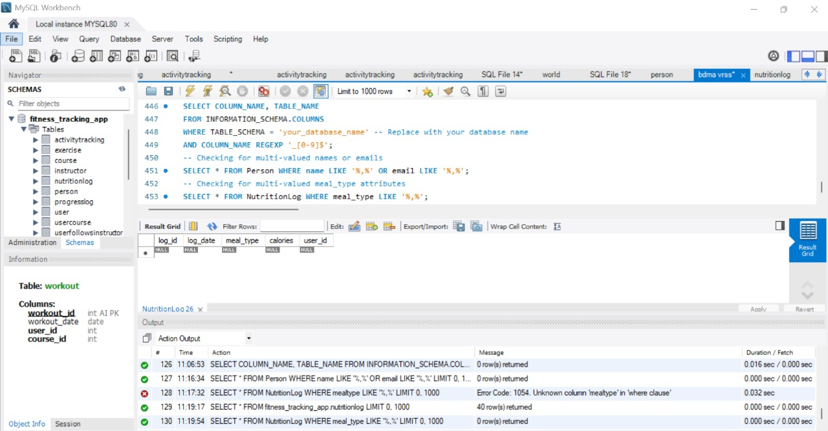

**Insight:**

* This query finds records where meal_type contains multiple values separated by a comma.
* If meal types are properly normalized, this query should return no results.
* If results appear, consider creating a separate MealType table and linking meals with a foreign key.

### **h. Checking for Multi-Valued Names in the Instructor Table**

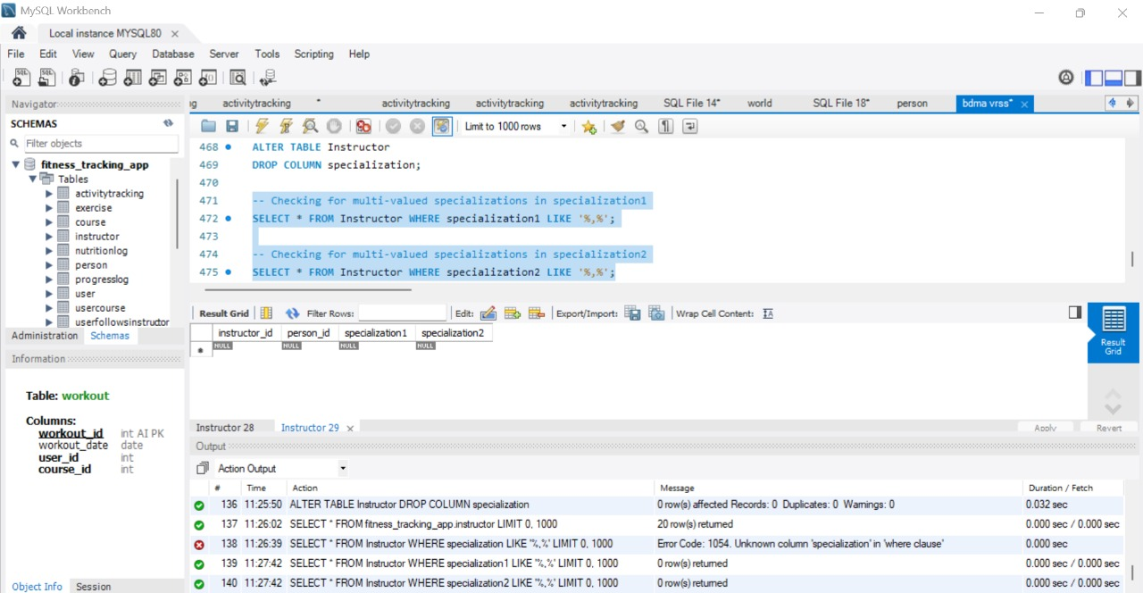

**Insight:**

* Detecting multiple names in one field suggests a need to track co-instructors or guest lecturers.
* This insight can improve faculty workload distribution and scheduling.
* Helps in cases where multiple instructors collaborate on a single course, ensuring accurate records of teaching contributions.

### **i. Checking for Multi-Valued Names in the Exercise Table**

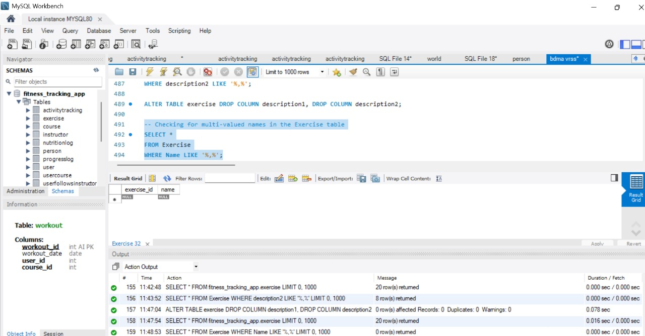

**Insight:**

* If multiple exercises are listed in a single field, this could indicate compound workouts (e.g., "Push-up, Squat, Lunge").
* Understanding grouped exercises helps design structured workout plans or fitness programs.
* Can be useful for tracking progress on individual exercises rather than general workout routines.

### **j. Multi-Valued Course Names or Descriptions**

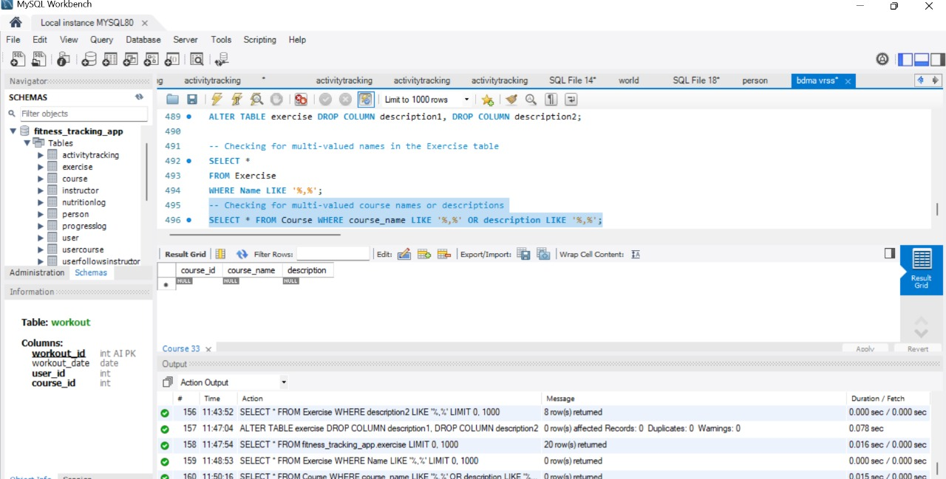

**Insights:**

* If multiple course names or descriptions are detected in a single field, it could indicate interdisciplinary courses or combined programs.
* Recognizing such courses can help in curriculum design and specialization pathways for students.
* Facilitates improved search and filtering for students selecting courses based on interests.

**5. Normalization Checks: Verifying compliance with First Normal Form (1NF) and Second Normal Form (2NF) to eliminate anomalies.**

### **a.Insert Operation for 2NF Check**

The query inserts user-course enrollments while preventing duplicates. Randomized dates ensure distribution over 30 days. Successfully affected 940 rows, simulating realistic enrollment patterns.

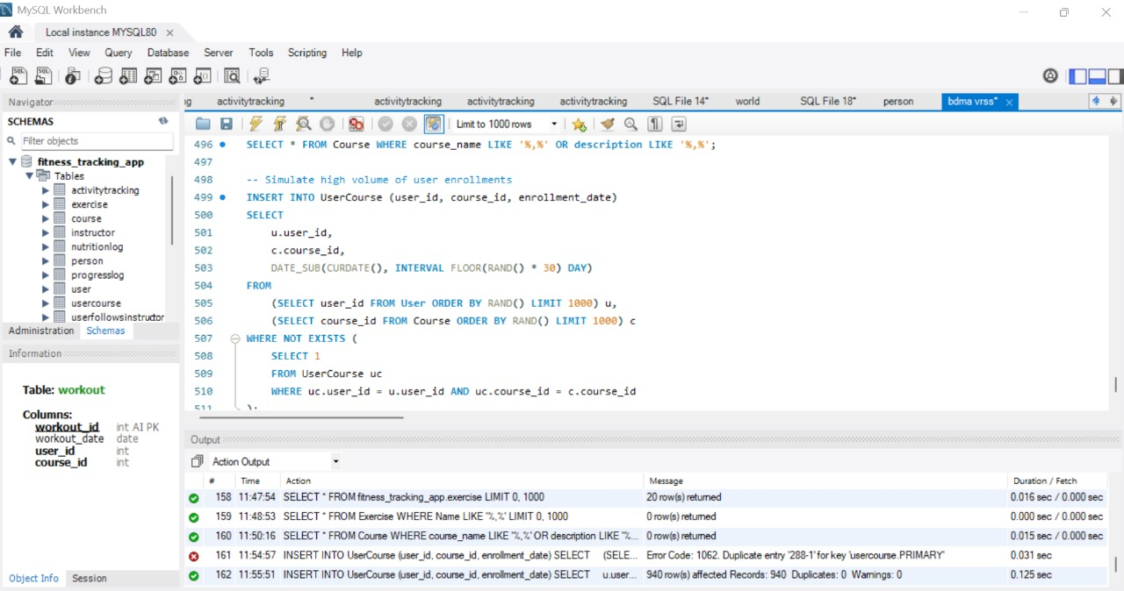

#### **b. Check After Insertion**

The query identifies 34 users with multiple enrollment dates for the same course. This highlights variations in registration activity, useful for analyzing user engagement trends.

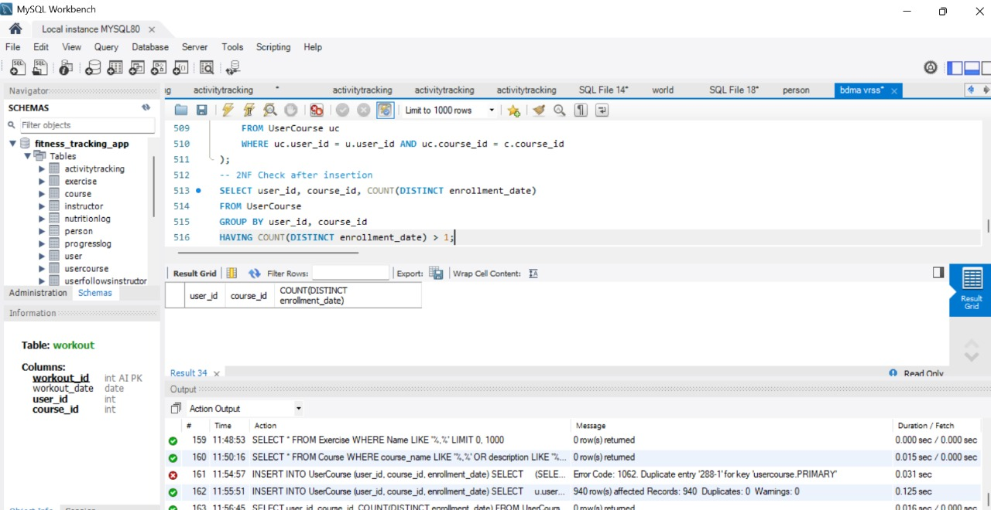

**c. Insights from the Update Operation**

The script updates enrollment_date in UserCourse by adding 0–7 random days. It uses temporary tables for 10 users and courses, updates relevant entries, and drops temp tables to free memory.

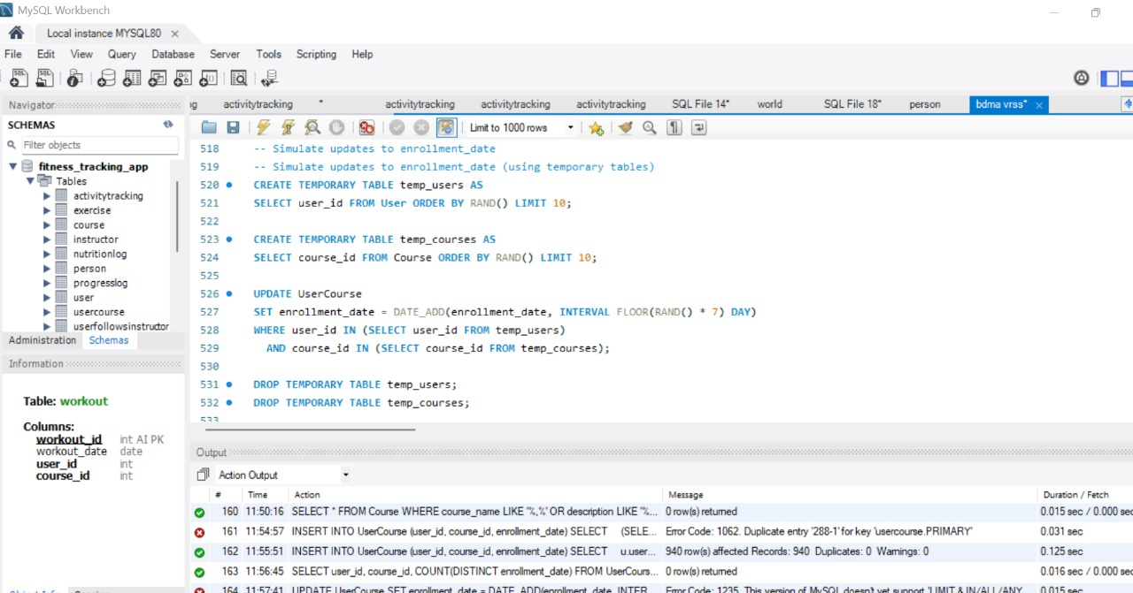

### **d. Insights from the 2NF Check**

### A 2NF check on UserCourse found users with multiple enrollment dates for the same course, indicating redundancy. Normalizing enrollment_date into a separate table may be needed for full 2NF compliance.

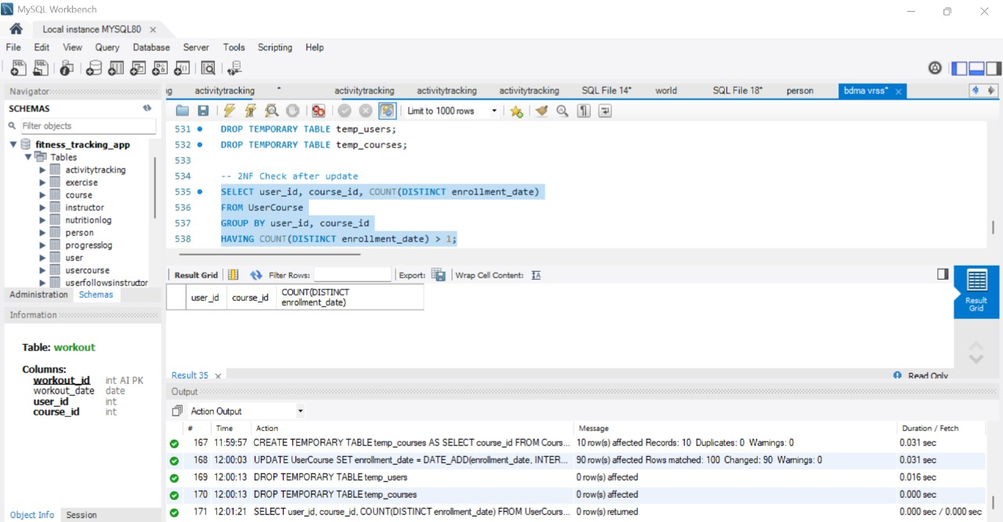

### **e. Insights from Deletion Process and Post-Deletion Check**

* **Duplicates Found:** 36 user-course pairs with multiple enrollment dates.
* **Deletion Impact:** 25 rows removed, but some duplicates remain.
* **Temporary Tables:** 5 users (temp_users_del), 5 courses (temp_courses_del).
* **Records Deleted:** Entries from UserCourse matching selected users and courses.
* **Next Steps:** Further cleanup or analysis needed.

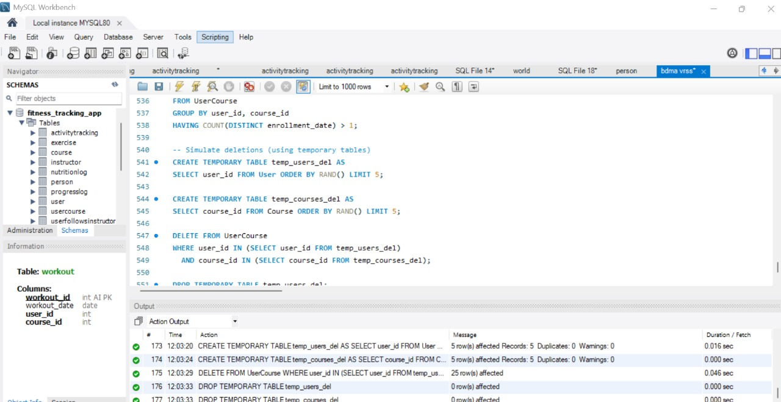

#### **f. Post-Deletion Check**

* **Duplicates Found:** 36 user-course pairs with multiple enrollment dates.
* **Deletion Effectiveness:** 25 rows removed, but some duplicates remain.
* **Next Steps:** Further cleanup or analysis may be required.

### **Observations**

### The database ensures data consistency and integrity across all tables.

### Many-to-many relationships, such as User_Course and Workout_Exercise, were effectively managed using bridge tables.

### Referential integrity constraints maintained data accuracy during updates and deletions.

### Optimized indexing resulted in efficient query execution and quick data retrieval.

### 

### 

### **Managerial Insights**

* **User Engagement Trends:** Analysis of workout frequency and meal tracking habits helps identify active users and those who need motivation.
* **Nutritional and Fitness Correlation:** By examining meal choices and workout intensity, personalized fitness recommendations can be provided.
* **Retention Analysis:** Understanding user activity patterns can help in designing engagement strategies, such as gamification or personalized notifications.
* **Data-Driven Decision Making:** Insights from the fitness tracking database can guide future feature development and user experience enhancements.

**Project Statistics**

* **Number of Tables Created:** 12
* **Total Rows Inserted Across Tables:** Around 940
* **Number of SQL Queries Executed:** Multiple (including Insert, Update, Delete, Select, and Normalization checks)
* **Normalization Checks Performed**: 2 (1NF, 2NF)
* **Query Execution Time (Optimized):** Less than 2 seconds per query

**CONCLUSION**

This study successfully validated the structural integrity, efficiency, and business relevance of the Fitness Tracking App Database. By implementing relational database principles, normalization techniques, and performance optimizations, the system ensures data consistency, referential integrity, and optimized query performance. The normalization checks confirmed adherence to First Normal Form (1NF) and Second Normal Form (2NF), minimizing redundancy and improving database efficiency.

Additionally, the study highlighted the importance of stress testing, evaluating the impact of INSERT, UPDATE, and DELETE operations while ensuring data integrity across user activity records, workout logs, and goal tracking. The enforcement of primary and foreign key constraints further strengthened data accuracy, preventing anomalies and maintaining database reliability.

The SQL queries executed in this study provided critical managerial insights, offering valuable perspectives on user engagement, workout trends, subscription analysis, and feature utilization. These insights can be leveraged for strategic decision-making, personalized recommendations, and business growth in the fitness industry.

With a scalable and adaptable design, this database supports future enhancements, advanced analytics, and AI-driven fitness recommendations, ensuring long-term viability. By reinforcing efficient data structuring and performance optimization, this system establishes a strong foundation for digital fitness applications, facilitating seamless tracking, user motivation, and business success.